**UNIT II – Week 4**

**ORGANIZATIONS, STRATEGY AND ETHICAL ISSUES IN INFORMATION SYSTEMS**

**Unit II Organizations, Strategy and Ethical Issues in Information Systems:** Impact of Information Systems on Organizations – Economic Impact – Organizational and Behavioural Impact

**__________________________________________________________________________________**

**Learning Objectives:**

1. Which features of organizations do managers need to know about to build and use information systems successfully?
2. What is the impact of information systems on organizations?

**__________________________________________________________________________________**

**Key Topics**

2.1 Introduction

2.2 Features of Organizations

2.3 Routines and Business Processes

2.4 Organizational Politics, Culture and Environments

2.5 Disruptive Technologies: Riding the Wave

2.6 Organizational Structure

2.7 What is the impact of information systems on organizations?

2.7.1 Economic Impact

2.7.2 Organizational and Behavioural Impact

**__________________________________________________________________________________**

**2.1 Introduction**

Information systems and organizations influence one another. Information systems are built by managers to serve the interests of the business firm. At the same time, the organization must be aware of and open to the influences of information systems to benefit from new technologies.

The interaction between information technology and organizations is complex and is influenced by many mediating factors, including the organization’s structure, business processes, politics, culture, surrounding environment, and management decisions (see Figure 2.1). You will need to understand how information systems can change social and work life in your firm. You will not be able to design new systems successfully or understand existing systems without understanding your own business organization.

As a manager, you will be the one to decide which systems will be built, what they will do, and how they will be implemented. You may not be able to anticipate all of the consequences of these decisions. Some of the changes that occur in business firms because of new information technology (IT) investments cannot be foreseen and have results that may or may not meet your expectations. Who would have imagined 15 years ago, for instance, that e-mail and instant messaging would become a dominant form of business communication and that many managers would be inundated with more than 200 e-mail messages each day?

**Figure 2.1 The Two-Way Relationship Between Organizations and Information Technology**

*This complex two-way relationship is mediated by many factors, not the least of which are the decisions made—or not made—by managers. Other factors mediating the relationship include the organizational culture, structure, politics, business processes, and environment.*

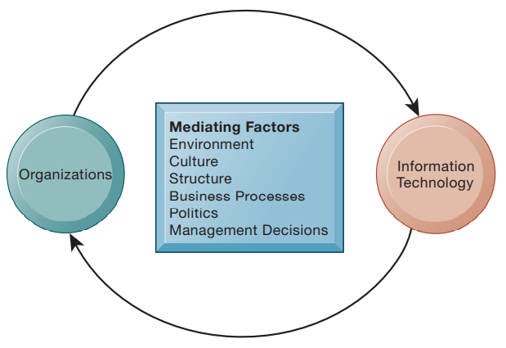

*What Is an Organization?* An organization is a stable, formal social structure that takes resources from the environment and processes them to produce outputs. This technical definition focuses on three elements of an organization. Capital and labor are primary production factors provided by the environment. The organization (the firm) transforms these inputs into products and services in a production function. The products and services are consumed by environments in return for supply inputs (see Figure 2.2).

**Figure 2.2 The Technical Microeconomic Definition of the Organization**

*In the microeconomic definition of organizations, capital and labor (the primary production factors provided by the environment) are transformed by the firm through the production process into products and services (outputs to the environment). The products and services are consumed by the environment, which supplies additional capital and labor as inputs in the feedback loop.*

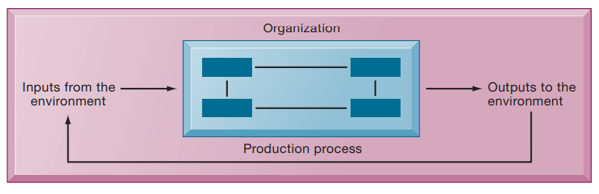

An organization is more stable than an informal group (such as a group of friends that meets every Friday for lunch) in terms of longevity and routineness. Organizations are formal legal entities with internal rules and procedures that must abide by laws. Organizations are also social structures because they are collections of social elements, much as a machine has a structure—a particular arrangement of valves, cams, shafts, and other parts. This definition of organizations is powerful and simple, but it is not very descriptive or even predictive of real-world organizations. A more realistic behavioral definition of an organization is a collection of rights, privileges, obligation and responsibilities delicately balanced over a period of time through conflict and conflict resolution (see Figure 2.3).

In this behavioral view of the firm, people who work in organizations develop customary ways of working; they gain attachments to existing relationships; and they make arrangements with subordinates and superiors about how work will be done, the amount of work that will be done, and under what conditions work will be done. Most of these arrangements and feelings are not discussed in any formal rulebook.

**Figure 2.3 The Behavioral View of Organizations**

*The behavioral view of organizations emphasizes group relationships, values, and structures.*

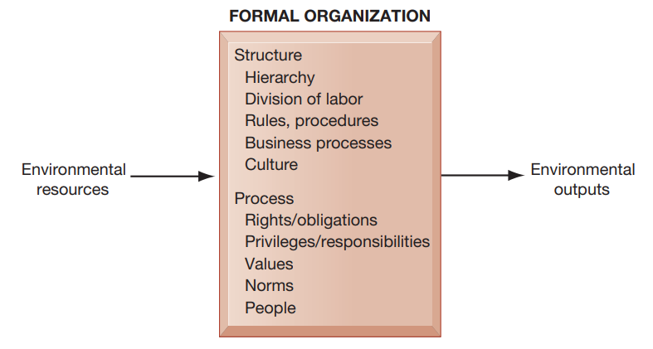

How do these definitions of organizations relate to information systems technology? A technical view of organizations encourages us to focus on how inputs are combined to create outputs when technology changes are introduced into the company. The firm is seen as infinitely malleable, with capital and labor substituting for each other quite easily. But the more realistic behavioral definition of an organization suggests that building new information systems, or rebuilding old ones, involves much more than a technical rearrangement of machines or workers—that some information systems change the organizational balance of rights, privileges, obligations, responsibilities, and feelings that have been established over a long period of time.

Changing these elements can take a long time, be very disruptive, and requires more resources to support training and learning. For instance, the length of time required to implement a new information system effectively is much longer than usually anticipated simply because there is a lag between implementing a technical system and teaching employees and managers how to use the system. Technological change requires changes in who owns and controls information, who has the right to access and update that information, and who makes decisions about whom, when, and how. This more complex view forces us to look at the way work is designed and the procedures used to achieve outputs.

The technical and behavioral definitions of organizations are not contradictory. Indeed, they complement each other: The technical definition tells us how thousands of firms in competitive markets combine capital, labor, and information technology, whereas the behavioral model takes us inside the individual firm to see how that technology affects the organization’s inner workings.

**2.2 Features of Organizations**

All modern organizations share certain characteristics. They are bureaucracies with clear-cut divisions of labor and specialization. Organizations arrange specialists in a hierarchy of authority in which everyone is accountable to someone and authority is limited to specific actions governed by abstract rules or procedures. These rules create a system of impartial and universal decision making. Organizations try to hire and promote employees on the basis of technical qualifications and professionalism (not personal connections). The organization is devoted to the principle of efficiency: maximizing output using limited inputs. Other features of organizations include their business processes, organizational culture, organizational politics, surrounding environments, structure, goals, constituencies, and leadership styles. All of these features affect the kinds of information systems used by organizations.

**2.3 Routines and Business Processes**

All organizations, including business firms, become very efficient over time because individuals in the firm develop **routines** for producing goods and services. Routines—sometimes called standard operating procedures—are precise rules, procedures, and practices that have been developed to cope with virtually all expected situations. As employees learn these routines, they become highly productive and efficient, and the firm is able to reduce its costs over time as efficiency increases. For instance, when you visit a doctor’s office, receptionists have a well-developed set of routines for gathering basic information from you, nurses have a different set of routines for preparing you for an interview with a doctor, and the doctor has a well-developed set of routines for diagnosing you. A business firm, in turn, is a collection of business processes (Figure 2.4).

**Figure 2.4 Routines, Business Processes, and Firms**

*All organizations are composed of individual routines and behaviors, a collection of which make up a business process. A collection of business processes makes up the business firm. New information system applications require that individual routines and business processes change to achieve high levels of organizational performance.*

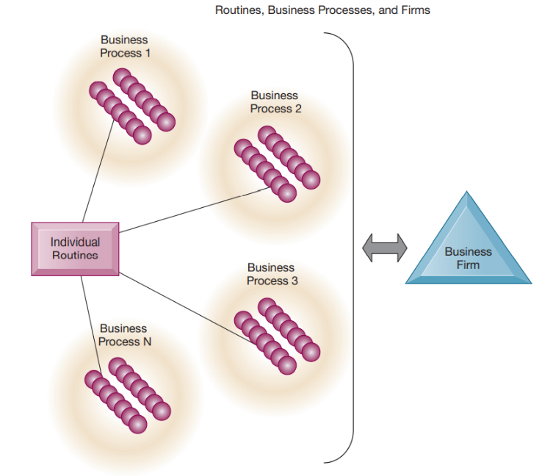

**2.4 Organizational Politics, Culture and Environments**

People in organizations occupy different positions with different specialties, concerns, and perspectives. As a result, they naturally have divergent viewpoints about how resources, rewards, and punishments should be distributed. These differences matter to both managers and employees, and they result in political struggles for resources, competition, and conflict within every organization. **Political resistance** is one of the great difficulties of bringing about organizational change—especially the development of new information systems. Virtually all large information systems investments by a firm that bring about significant changes in strategy, business objectives, business processes, and procedures become politically charged events. Managers who know how to work with the politics of an organization will be more successful than less skilled managers in implementing new information systems.

All organizations have bedrock, unassailable, unquestioned (by the members) assumptions that define their goals and products. **Organizational culture** encompasses this set of assumptions about what products the organization should produce, how it should produce them, where, and for whom. Generally, these cultural assumptions are taken totally for granted and are rarely publicly announced or discussed. Business processes—the actual way business firms produce value—are usually ensconced in the organization’s culture.

You can see organizational culture at work by looking around your university or college. Some bedrock assumptions of university life are that professors know more than students, the reason students attend college is to learn, and classes follow a regular schedule. Organizational culture is a powerful unifying force that restrains political conflict and promotes common understanding, agreement on procedures, and common practices. If we all share the same basic cultural assumptions, agreement on other matters is more likely.

At the same time, organizational culture is a powerful restraint on change, especially technological change. Most organizations will do almost anything to avoid making changes in basic assumptions. Any technological change that threatens commonly held cultural assumptions usually meets a great deal of resistance. However, there are times when the only sensible way for a firm to move forward is to employ a new technology that directly opposes an existing organizational culture. When this occurs, the technology is often stalled while the culture slowly adjusts.

Organizations reside in environments from which they draw resources and to which they supply goods and services. **Organizations and environments** have a reciprocal relationship. On the one hand, organizations are open to and dependent on the social and physical environment that surrounds them. Without financial and human resources—people willing to work reliably and consistently for a set wage or revenue from customers—organizations could not exist. Organizations must respond to legislative and other requirements imposed by government as well as the actions of customers and competitors. On the other hand, organizations can influence their environments. For example, business firms form alliances with other businesses to influence the political process; they advertise to influence customer acceptance of their products.

Figure 2.5 illustrates the role of information systems in helping organizations perceive changes in their environments and also in helping organizations act on their environments. Information systems are key instruments for environmental scanning, helping managers identify external changes that might require an organizational response.

Environments generally change much faster than organizations. New technologies, new products, and changing public tastes and values (many of which result in new government regulations) put strains on any organization’s culture, politics, and people. Most organizations are unable to adapt to a rapidly changing environment. Inertia built into an organization’s standard operating procedures, the political conflict raised by changes to the existing order, and the threat to closely held cultural values inhibit organizations from making significant changes. Young firms typically lack resources to sustain even short periods of troubled times. It is not surprising that only 10 percent of the Fortune 500 companies in 1919 still exist today.

**Figure 2.5 Environments and Organizations have a Reciprocal Relationship**

*Environment’s shape what organizations can do, but organizations can influence their environments and decide to change environments altogether. Information technology plays a critical role in helping organizations perceive environmental change and in helping organizations act on their environment.*

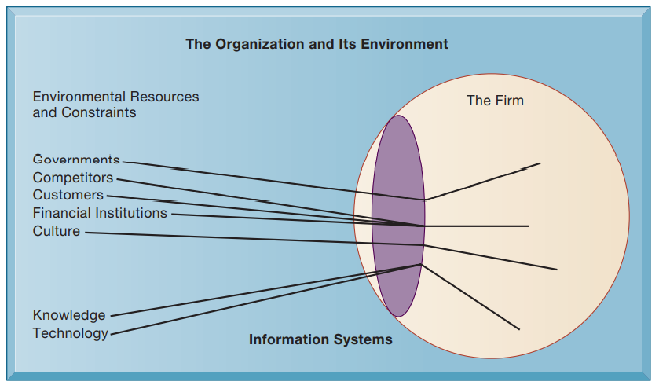

**2.5 Disruptive Technologies: Riding the Wave**

Sometimes a technology and resulting business innovation come along to radically change the business landscape and environment. These innovations are loosely called “disruptive” (Christensen, 2003; Christensen, Raynor, and McDonald, 2015). What makes a technology disruptive? In some cases**, disruptive technologies** are substitute products that perform as well as or better (often much better) than anything currently produced. The car substituted for the horse-drawn carriage, the word processor for typewriters, the Apple iPod and streaming music service for portable CD players, and digital photography for process film photography. Table 2.1 describes just a few disruptive technologies from the past. In these cases, entire industries were put out of business.

In other cases, disruptive technologies simply extend the market, usually with less functionality and much less cost than existing products. Eventually they turn into low-cost competitors for whatever was sold before. Disk drives are an example: Small hard disk drives used in PCs extended the market for disk drives by offering cheap digital storage for small files. Eventually, small PC hard disk drives became the largest segment of the disk drive marketplace.

Some firms are able to create these technologies and ride the wave to profits; others learn quickly and adapt their business; still others are obliterated because their products, services, and business models become obsolete. They may be very efficient at doing what no longer needs to be done! There are also cases where no firms benefit and all the gains go to consumers (firms fail to capture any profits). Moreover, not all change or technology is disruptive (King and Baatartogtokh, 2015).

**Table 2.1 Disruptive Technologies: Winners and Losers**

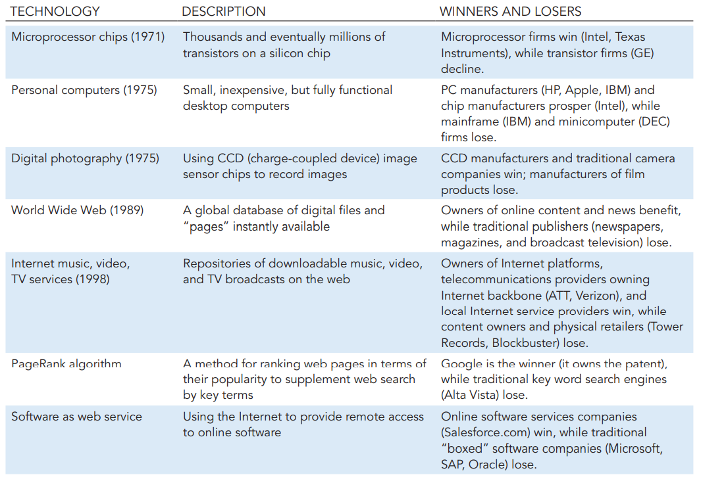

Managers of older businesses often do make the right decisions and find ways to continue competing. Disruptive technologies are tricky. Firms that invent disruptive technologies as “first movers” do not always benefit if they lack the resources to exploit the technology or fail to see the opportunity. The MITS Altair 8800 is widely regarded as the first PC, but its inventors did not take advantage of their first mover status. Second movers, so-called “fast followers,” such as IBM and Microsoft, reaped the rewards. Citibank’s ATMs revolutionized retail banking, but they were copied by other banks. Now all banks use ATMs, with the benefits going mostly to the consumers.

**2.6 Organizational Structure**

All organizations have a structure or shape. Mintzberg’s classification, described in Table 2.2, identifies five basic kinds of organizational structure (Mintzberg, 1971).

The kind of information systems you find in a business firm—and the nature of problems with these systems—often reflects the type of organizational structure. For instance, in a professional bureaucracy such as a hospital, it is not unusual to find parallel patient record systems operated by the administration, another by doctors, and another by other professional staff such as nurses and social workers. In small entrepreneurial firms, you will often find poorly designed systems developed in a rush that quickly outgrow their usefulness. In huge multidivisional firms operating in hundreds of locations, you will frequently find there is not a single integrating information system, but instead each locale or each division has its own set of information systems.

**Table 2.2 Organizational Structures**

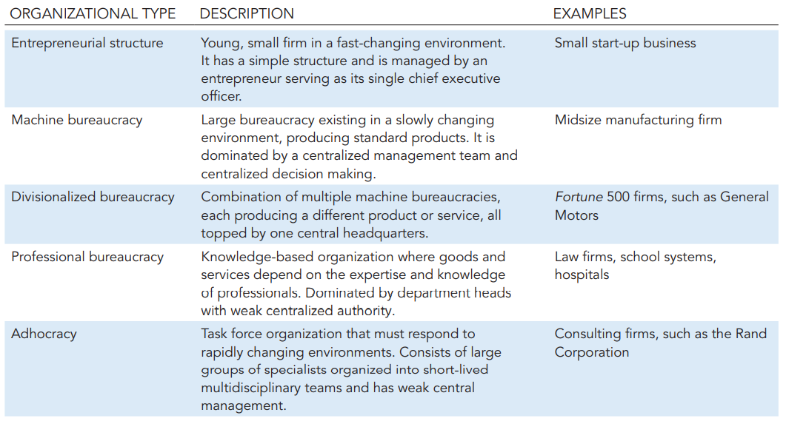

Other Organizational Features:

Organizations have goals and use different means to achieve them. Some organizations have coercive goals (e.g., prisons); others have utilitarian goals (e.g., businesses). Still others have normative goals (universities, religious groups). Organizations also serve different groups or have different constituencies, some primarily benefiting their members, others benefiting clients, stockholders, or the public. The nature of leadership differs greatly from one organization to another—some organizations may be more democratic or authoritarian than others. Another way organization differ is by the tasks they perform and the technology they use. Some organizations perform primarily routine tasks that can be reduced to formal rules that require little judgment (such as manufacturing auto parts), whereas others (such as consulting firms) work primarily with nonroutine tasks.

**2.7 What is the impact of information systems on organizations?**

Information systems have become integral, online, interactive tools deeply involved in the minute-to-minute operations and decision making of large organizations. Over the past decade, information systems have fundamentally altered the economics of organizations and greatly increased the possibilities for organizing work. Theories and concepts from economics and sociology help us understand the changes brought about by IT.

**2.7.1 Economic Impacts**

From the point of view of economics, IT changes both the relative costs of capital and the costs of information. Information systems technology can be viewed as a factor of production that can be substituted for traditional capital and labor. As the cost of information technology decreases, it is substituted for labor, which historically has been a rising cost. Hence, information technology should result in a decline in the number of middle managers and clerical workers as information technology substitutes for their labor.

As the cost of information technology decreases, it also substitutes for other forms of capital such as buildings and machinery, which remain relatively expensive. Hence, over time we should expect managers to increase their investments in IT because of its declining cost relative to other capital investments.

IT also affects the cost and quality of information and changes the economics of information. Information technology helps firms contract in size because it can reduce transaction costs—the costs incurred when a firm buy on the marketplace what it cannot make itself. According to transaction cost theory, firms and individuals seek to economize on transaction costs, much as they do on production costs. Using markets is expensive because of costs such as locating and communicating with distant suppliers, monitoring contract compliance, buying insurance, obtaining information on products, and so forth (Coase, 1937; Williamson, 1985). Traditionally, firms have tried to reduce transaction costs through vertical integration, by getting bigger, hiring more employees, and buying their own suppliers and distributors, as both General Motors and Ford used to do.

Information technology, especially the use of networks, can help firms lower the cost of market participation (transaction costs), making it worthwhile for firms to contract with external suppliers instead of using internal sources. As a result, firms can shrink in size (numbers of employees) because it is far less expensive to outsource work to a competitive marketplace rather than hire employees.

For instance, by using computer links to external suppliers, automakers such as Chrysler, Toyota, and Honda can achieve economies by obtaining more than 70 percent of their parts from the outside. Information systems make it possible for companies such as Apple Cisco Systems and Dell Inc. to outsource assembly of iPhones to contract manufacturers such as Foxconn instead of making their products themselves.

As transaction costs decrease, firm size (the number of employees) should shrink because it becomes easier and cheaper for the firm to contract for the purchase of goods and services in the marketplace rather than to make the product or offer the service itself. Firm size can stay constant or contract even as the company increases its revenues. For example, when Eastman Chemical Company split off from Kodak in 1994, it had $3.3 billion in revenue and 24,000 full-time employees. In 2017, it generated $9.5 billion in revenue with only 14,500 employees.

Information technology also can reduce internal management costs. According to agency theory, the firm is viewed as a “nexus of contracts” among self-interested individuals rather than as a unified, profit-maximizing entity (Jensen and Meckling, 1976). A principal (owner) employs “agents” (employees) to perform work on his or her behalf. However, agents need constant supervision and management; otherwise, they will tend to pursue their own interests rather than those of the owners. As firms grow in size and scope, agency costs or coordination costs rise because owners must expend more and more effort supervising and managing employees.

Information technology, by reducing the costs of acquiring and analyzing information, permits organizations to reduce agency costs because it becomes easier for managers to oversee a greater number of employees. By reducing overall management costs, information technology enables firms to increase revenues while shrinking the number of middle managers and clerical workers. We have seen examples in earlier chapters where information technology expanded the power and scope of small organizations by enabling them to perform coordinated activities such as processing orders or keeping track of inventory with very few clerks and managers.

Because IT reduces both agency and transaction costs for firms, we should expect firm size to shrink over time as more capital is invested in IT. Firms should have fewer managers, and we expect to see revenue per employee increase over time.

**2.7.2 Organizational and Behavioral Impacts**

Theories based in the sociology of complex organizations also provide some understanding about how and why firms change with the implementation of new IT applications.

*IT Flattens Organizations:*

Large, bureaucratic organizations, which primarily developed before the computer age, are often inefficient, slow to change, and less competitive than newly created organizations. Some of these large organizations have downsized, reducing the number of employees and the number of levels in their organizational hierarchies.

Behavioral researchers have theorized that information technology facilitates flattening of hierarchies by broadening the distribution of information to empower lower-level employees and increase management efficiency (see Figure 2.6). IT pushes decision-making rights lower in the organization because lower-level employees receive the information they need to make decisions without supervision. (This empowerment is also possible because of higher educational levels among the workforce, which give employees more capabilities to make intelligent decisions.) Because managers now receive so much more accurate information on time, they become much faster at making decisions, so fewer managers are required. Management costs decline as a percentage of revenues, and the hierarchy becomes much more efficient.

These changes mean that the management span of control has also been broadened, enabling high-level managers to manage and control more workers spread over greater distances. Many companies have eliminated thousands of middle managers as a result of these changes.

**FIGURE 2.6 FLATTENING ORGANIZATIONS**

*Information systems can reduce the number of levels in an organization by providing managers with information to supervise larger numbers of workers and by giving lower-level employees more decision-making authority.*

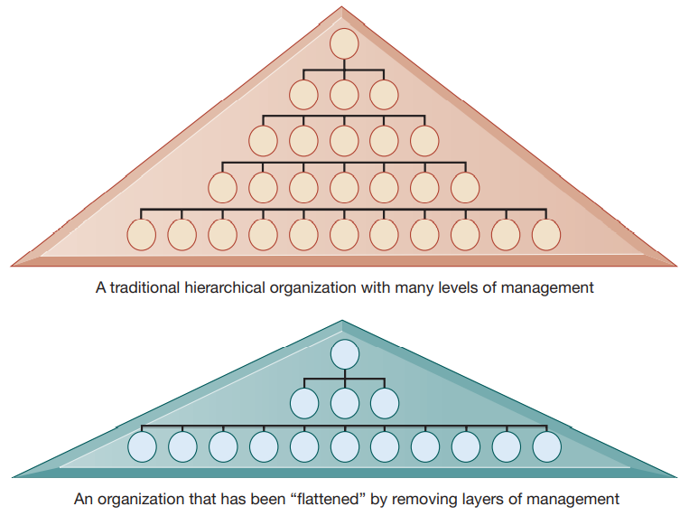

*Postindustrial Organizations:*

Postindustrial theories based more on history and sociology than economics also support the notion that IT should flatten hierarchies. In postindustrial societies, authority increasingly relies on knowledge and competence and not merely on formal positions. Hence, the shape of organizations flattens because professional workers tend to be self-managing, and decision making should become more decentralized as knowledge and information become more widespread throughout the firm.

Information technology may encourage task force–networked organizations in which groups of professionals come together—face-to-face or electronically— for short periods of time to accomplish a specific task (e.g., designing a new automobile); once the task is accomplished, the individuals join other task forces. The global consulting service Accenture is an example. Many of its 373,000 employees move from location to location to work on projects at client locations in more than 56 different countries.

Who makes sure that self-managed teams do not head off in the wrong direction? Who decides which person works on which team and for how long? How can managers evaluate the performance of someone who is constantly rotating from team to team? How do people know where their careers are headed? New approaches for evaluating, organizing, and informing workers are required, and not all companies can make virtual work effective.

*Understanding Organizational Resistance to Change:*

Information systems inevitably become bound up in organizational politics because they influence access to a key resource—namely, information. Information systems can affect who does what to whom, when, where, and how in an organization. Many new information systems require changes in personal, individual routines that can be painful for those involved and require retraining and additional effort that may or may not be compensated. Because information systems potentially change an organization’s structure, culture, business processes, and strategy, there is often considerable resistance to them when they are introduced.

There are several ways to visualize organizational resistance. Research on organizational resistance to innovation suggests that four factors are paramount: the nature of the IT innovation, the organization’s structure, the culture of people in the organization, and the tasks affected by the innovation (see Figure 2.7).

**Figure 2.7 Organizational Resistance to Information System Innovations**

*Implementing information systems has consequences for task arrangements, structures, and people. According to this model, to implement change, all four components must be changed simultaneously.*

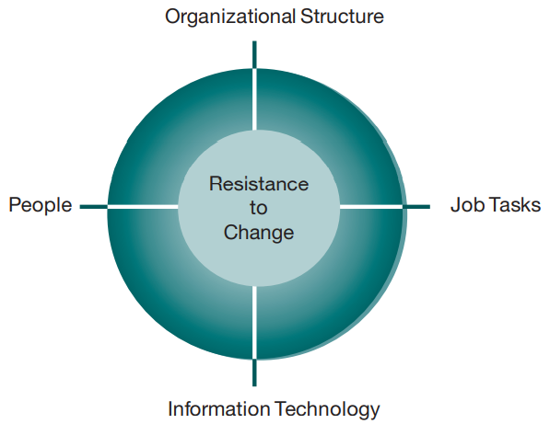

Here, changes in technology are absorbed, interpreted, deflected, and defeated by organizational task arrangements, structures, and people. In this model, the only way to bring about change is to change the technology, tasks, structure, and people simultaneously. Other authors have spoken about the need to “unfreeze” organizations before introducing an innovation, quickly implementing it, and “refreezing” or institutionalizing the change (Kolb and Frohman, 1970).

Because organizational resistance to change is so powerful, many information technology investments flounder and do not increase productivity. Indeed, research on project implementation failures demonstrates that the most common reason for failure of large projects to reach their objectives is not the failure of the technology but organizational and political resistance to change. Therefore, as a manager involved in future IT investments, your ability to work with people and organizations is just as important as your technical awareness and knowledge.

*The Internet and Organizations:*

The Internet, especially the World Wide Web, has an important impact on the relationships between many firms and external entities and even on the organization of business processes inside a firm. The Internet increases the accessibility, storage, and distribution of information and knowledge for organizations. In essence, the Internet is capable of dramatically lowering the transaction and agency costs facing most organizations. For instance, a global sales force can receive nearly instant product price information updates using the web or instructions from management sent by e-mail or text messaging on smartphones or mobile laptops. Vendors of some large retailers can access retailers’ internal websites directly to find up-to-the-minute sales information and to initiate replenishment orders instantly.

Businesses are rapidly rebuilding some of their key business processes based on Internet technology and making this technology a key component of their IT infrastructures. If prior networking is any guide, one result will be simpler business processes, fewer employees, and flatter organizations than in the past.

*Implications for the Design and Understanding of Information Systems*:

To deliver genuine benefits, information systems must be built with a clear understanding of the organization in which they will be used. In our experience, the central organizational factors to consider when planning a new system are the following:

• The environment in which the organization must function

• The structure of the organization: hierarchy, specialization, routines, and business processes

• The organization’s culture and politics

• The type of organization and its style of leadership

• The principal interest groups affected by the system and the attitudes of workers who will be using the system

• The kinds of tasks, decisions, and business processes that the information system is designed to assist